**Project Design Phase-II**

**Data Flow Diagram & User Stories**

|  |  |
| --- | --- |
| Date | 31 January 2025 |
| Team ID | SWTID1741256970149949 |
| Project Name | Rhythmic Tunes |
| Maximum Marks | 4 Marks |

**Data Flow Diagrams:**

· **External Entities (Musicians/Listeners):**  
These are the sources or destinations of musical data. For example, a musician might submit a raw rhythmic pattern (input), and a listener receives the synthesized tune (output).

· · **Processes (Musical Operations):**  
These represent the activities or functions that transform the data. Imagine these as the various instrumental sections in an orchestra: one process might capture and clean up the raw beats (Input Module), another might analyze the rhythm to extract the core beats (Rhythm Analyzer), and yet another might blend these elements into a full arrangement (Sound Synthesizer).

· · **Data Stores (Musical Archives):**  
These are repositories where the musical data is stored. Think of them as libraries of scores or recordings where the rhythmic patterns and tunes are kept for future use.

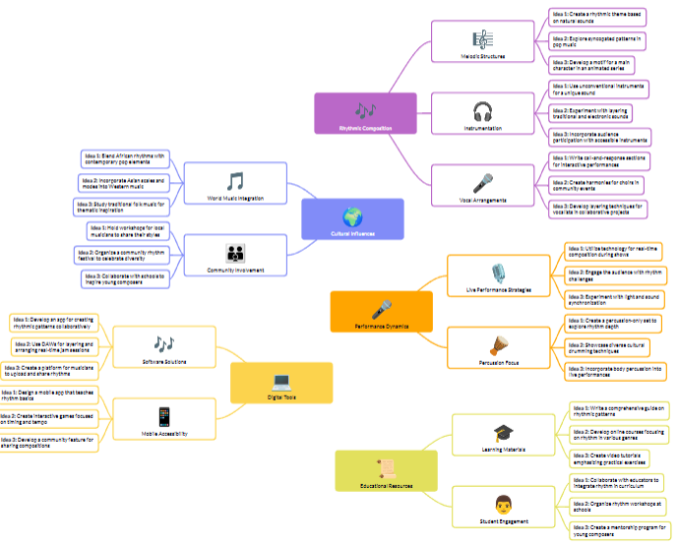

**User Stories**

**User Story Table – Music Streaming App**

